Marcella’s Henna Mix Recipe for no-fail stain

Items you will need:
- Henna
  - Body-Art Quality Henna purchased from mehandi.com (This year, the Rajasthani Twilight is the best henna stain that I’ve gotten). This henna is $8.00 for 100g which is enough for a small henna party depending on the size of your designs and whether you do palms and back of hands or feet/other body parts. http://www.mehandi.com/shop/purityskin/index.html
- Lemon or Lime juice
  - 100% lemon or lime juice – either from fresh lemon or tarantillo bottled juice.
- Plain old white sugar
  - The stuff that’s bad for you to eat in large amounts. Just remember, YOU CANNOT EAT HENNA
- Chamomile tea
  - Any brand, brew about 8oz like you would if you were drinking the tea
- A plastic container
  - (yogurt, guacamole, margarine, any CLEAN container with a lid that you won’t reuse for food)
- A mixing utensil
  - that you will not reuse for food: popsicle sticks and plastic forks/spoons/knives are good choices
- Newspaper
  - to catch any henna – remember this is a STAIN and it will color things you may not want colored.
- Resealable plastic bags
  - snack bags are best because they’re small, but sandwich bags will work too.
- Optional items
  - Hair spray, additional lemon juice and sugar, or glue and water
    - Helps hold down your henna design
    - Lemon juice and sugar holds down your design without the use of chemicals on your skin.
    - White glue and water also does this
  - Squeeze bottles for painting, batik to apply your henna
  - Mylar cones to apply your henna
  - Glitter to accent your henna
  - Old winter gloves or mittens
    - To protect your henna design overnight – the longer your henna paste stays on, the darker it will stain
  - Steam/Sun/other heat
    - Helps your henna to stain darker
  - Eucalyptus, lavender, rosemary or tea tree ESSENTIAL OIL to help darken the stain. You can find this at health food/vitamin stores.
    - * This may cause an allergic reaction if you have allergies, sensitive skin or conditions like eczema, or psoriasis, you should skip this step to avoid aggravating your condition.

Making your Henna Mix
Begin on a Wednesday or Thursday if you would like your henna to be ready for the weekend.

- On Thursday night, mix enough henna and lemon or lime juice until it is the consistency of mashed potatoes. It’s okay if it appears a bit lumpy but mix out as many lumps as you can.
- Sit your henna outside in a place that will catch a lot of sun on Friday.
- When you get home from school, check your Henna. When you carefully open the container, you should see some brownish/reddish liquid collecting. This is good, it means your henna is releasing the dye that will color your hands!
- Use your mixing tool to mix your henna. This is helping to distribute the dye evenly and continue the release process.
- Return your henna to its sunny location.
- Bring your henna indoors after the sun goes down and mix it again. The heat from the sun and the lemon juice should eliminate most of the lumps in your mix.
- *If you choose to add essential oils, you will do so now.
- You will also add a little sugar – ½ teaspoon for every 50g of henna (you don’t have to be so approximate. A little more or less won’t hurt your henna mix) This is added to help your henna spread easily. Most people say it makes it ‘stringier’ for fine lines and detailed designs.
- You may let your henna sit for a few hours or overnight again. By the next morning, it’s ready for use.

Preparing to use your henna
- Mehandi.com recommends straining your henna through a pair of nylons (pantyhose). I haven’t found this step necessary for the Rajasthani twilight (the henna you will use in the Splash session.)

- Use a plastic or compostable spoon to scoop your henna into a resealable sandwich (not snack) bag.

- Roll your cone which will become your ‘henna pen.’ (We will review this technique in the session)

- Cut a small corner of the bag to help you squeeze the henna into the cone and you’re ready to begin!

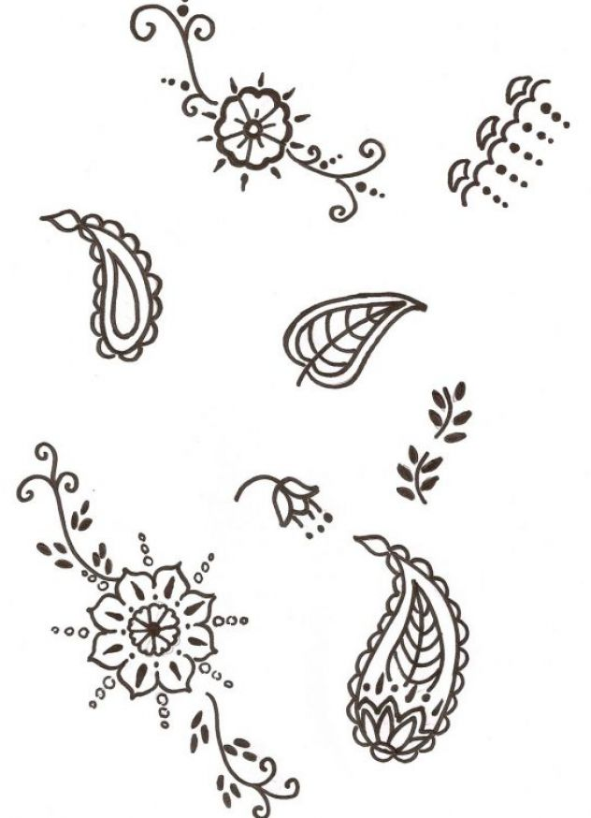
- **Freeze any henna that you are not using. Some believe that freezing the henna produces a darker stain. Freezing henna certainly slows down the dye release process keeping your henna as fresh as possible. Likewise, if you have leftover powder, place it in a resealable sandwich bag and store in the freezer. Some ideas for inspiration:

