Sounds of the World

 |  | bilab. | lab.-dent. | dent. | alv. | post-alv. | retro-flex | pal. | velar | uvul. | phar. | glot.
plosive | voiceless | p |  | t |  |  | ʈ | c | k | q |  | ʔ
plosive | voiced | b |  | d |  |  | ɖ | ɟ | g | ɢ
nasal |  | m | ɱ | n |  |  | ɳ | ɲ | ŋ | ɴ
trill |  | ʙ |  | r |  |  |  |  |  | ʀ
tap |  |  |  | ɾ |  |  | ɽ
fricative | voiceless | ɸ | f | θ | s | ʃ | ʂ | ç | x | χ | ħ | h
fricative | voiced | β | v | ð | z | ʒ | ʐ | ʝ | ɣ | ʁ | ʕ | ɦ
lateral fricative | voiceless |  |  | ɬ
lateral fricative | voiced |  |  | ɮ
approximant |  | w | ʋ | ɹ |  |  | ɻ | j | ɰ
lateral |  |  |  | l |  |  | ɭ | ʎ | ʟ

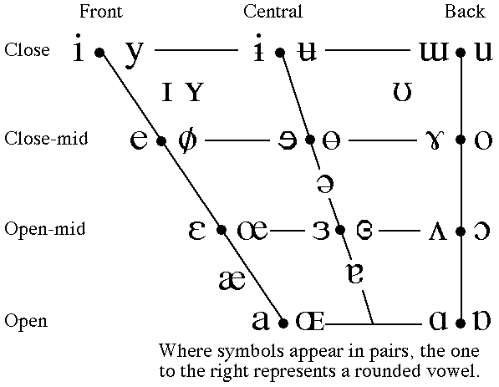
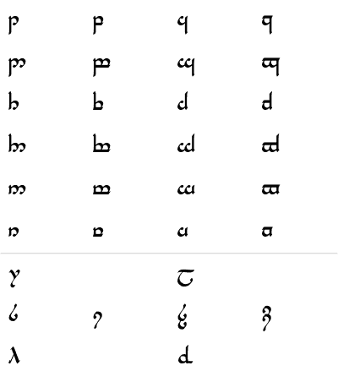
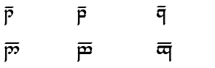
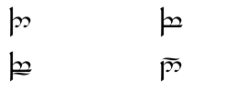
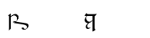
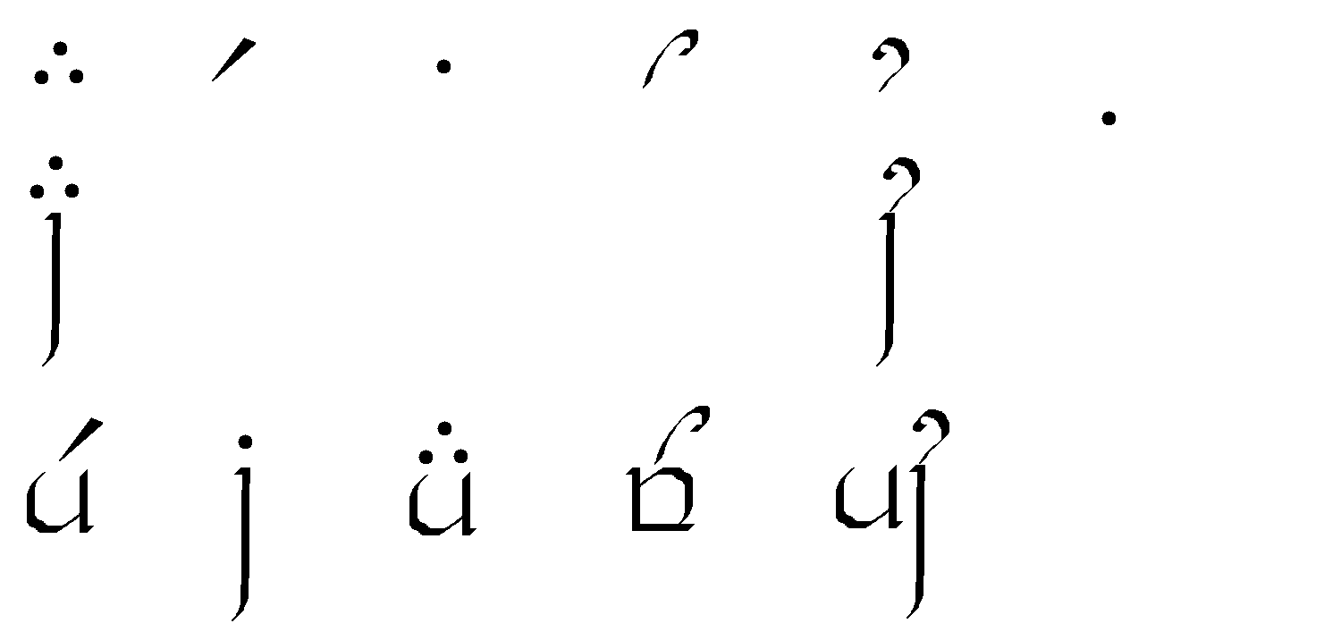
The Tengwar

